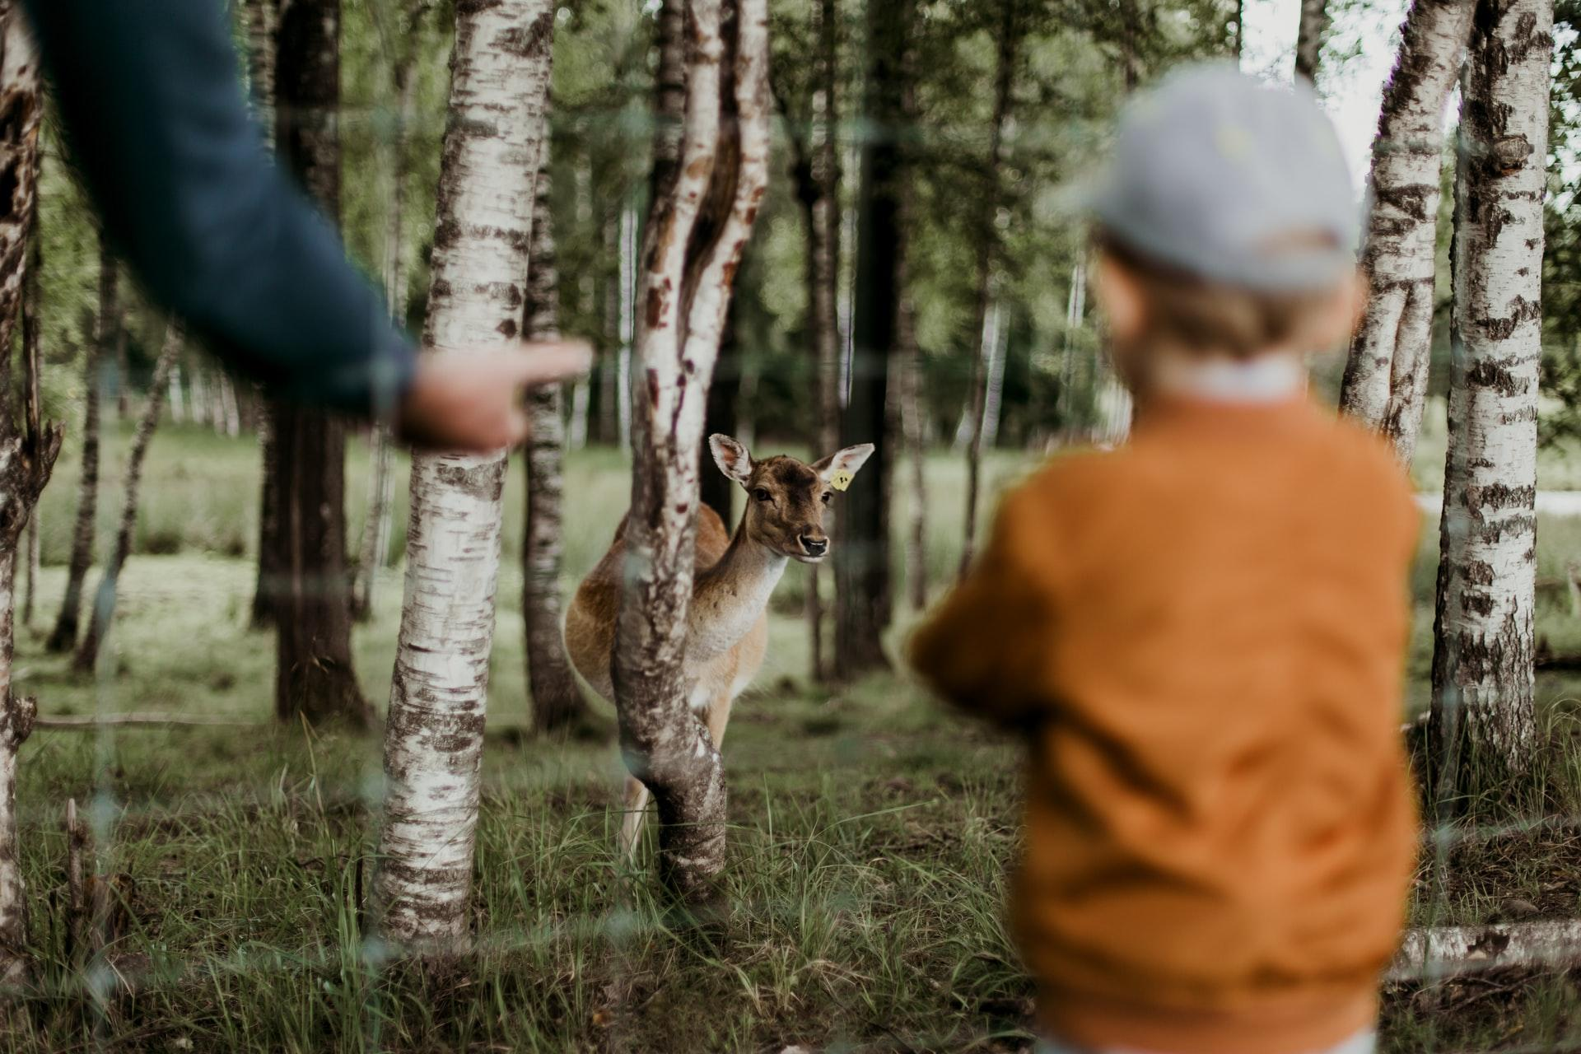

Does Your Child Have Nature Deficit Disorder?
Nature-deficit disorder isn’t a diagnosis you’ll hear at the pediatrician’s office. Nonetheless, it’s a big concern for parents today. One study revealed that most American children only spend 4 to 7 minutes outside for unstructured play, compared to more than 7 hours a day of screen time. As a result, they’re missing out on many important benefits of nature that will benefit them physically and mentally. Ready to help your child embrace the outdoors? Then check out this resource guide.

What Is Nature Deficit Disorder?
All you need to know about nature deficit disorder.
What is nature deficit disorder and how to know if you have it.

What Are the Benefits of the Outdoors?
Why kids need to spend time in nature.
Childhood obesity and outdoor play.
Sour mood getting you down? Get back to nature.

How to Get Kids to Spend More Time Outdoors
10 tips for raising outdoors-loving kids.
How to turn off screen time without a struggle.
These 10 outdoorsy organizations make it easy to raise a nature lover.
Childhood unplugged: The benefits of outdoor travel for children.

Fun Ways to Encourage Outdoor Play
14 ideas for a kid-friendly backyard play area.
25 easy backyard games to rock your summer.
6 mind-blowing backyard science experiments for kids.

Outdoor Activities for Children and Families
Explore the different trails in Westmoreland County.
4 tips while mountain biking with your child.
Find the best camping near me.
Storm spotting for children: At-home meteorology.

Convincing screen-addicted kids to spend more time outdoors can be a struggle. But for parents, it’s a battle worth fighting. Time in nature is linked to better health and happier kids, making getting outdoors one of the best things you can do for your children’s well-being.

Image via Unsplash

